SDC250 Final Exam

For each question, fill in one SQL statement, and a screen shot of the output. Please paste the answers below the questions in this document.
Good Luck!

- Using the course table, find all the courses that cost less than the average course price. Show description, course_no, and cost in your results. Order by cost in descending order. Make sure your cost is in $9,999 format <Hint: Use the to_char statement to format your answer>

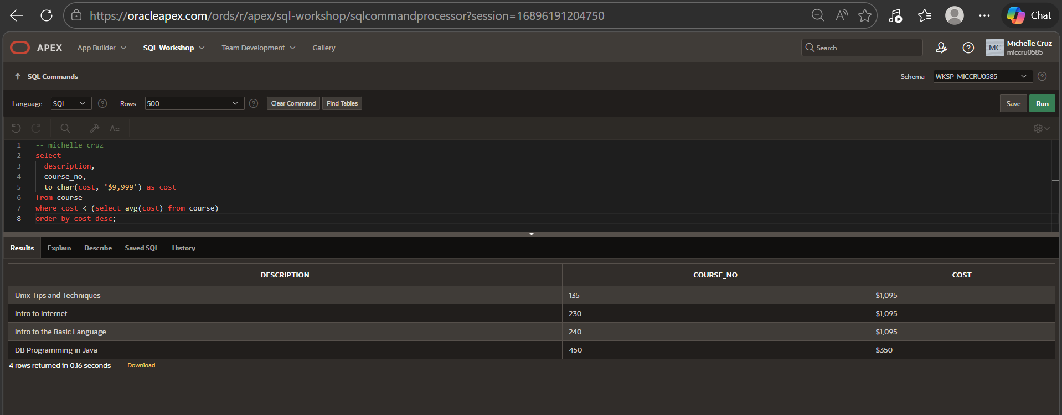

- Using the course and section tables, list all the courses and their corresponding sections. Show course_no, description, cost, start_date_time in your results. Order your results by course_no, then description. Make sure that your course_no, description, and cost do not duplicate in the display of your results.
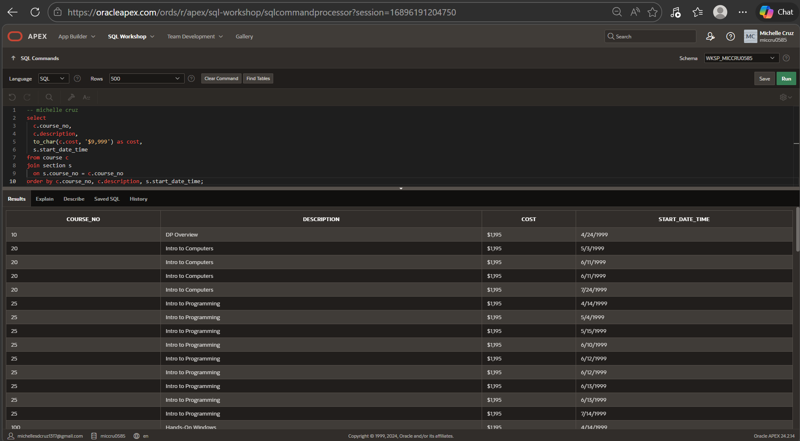

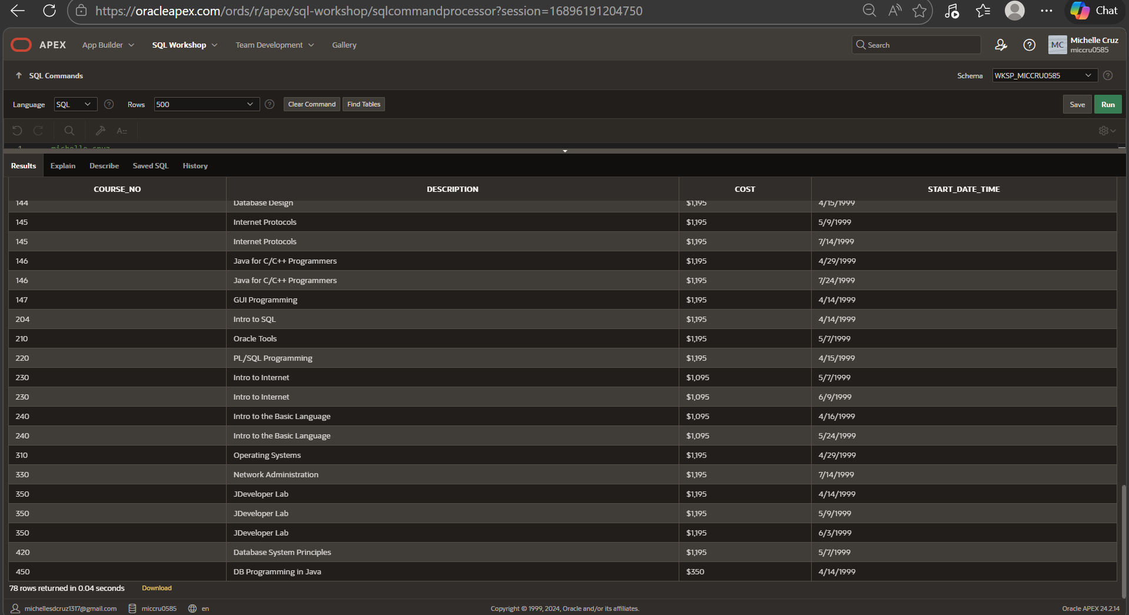

- Using the zipcode and instructor table, show all the zipcodes and the count of instructors that live in those zipcodes.

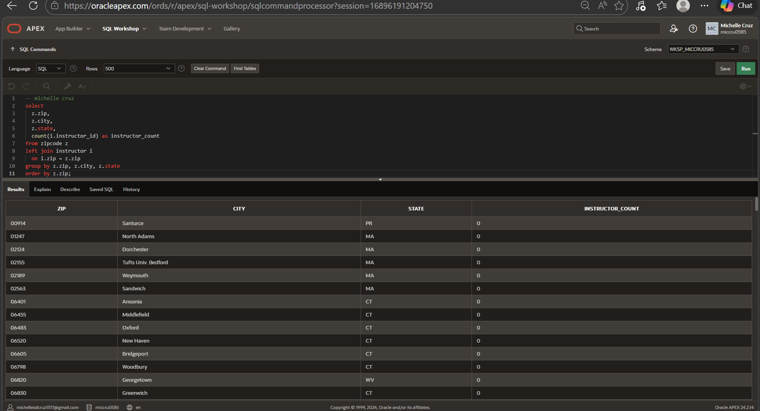
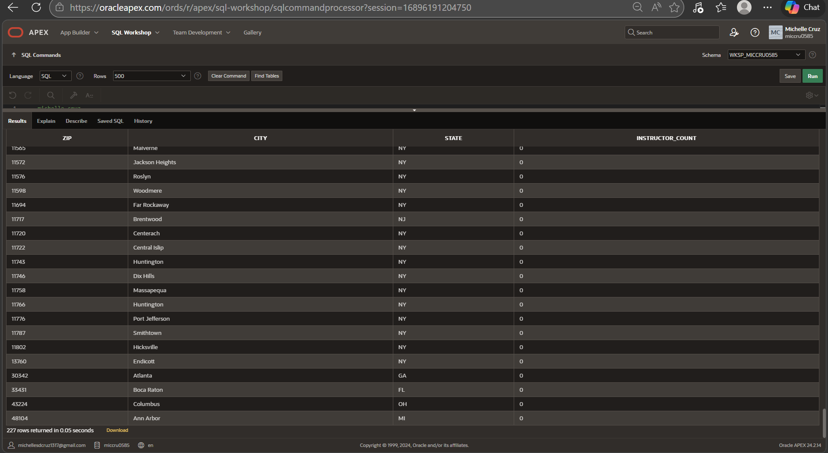

- Using the zipcode and student table, show all the students that live in Brooklyn. Show student_id, first_name, last_name, street_address, state, and zip in your results. Order your results by last_name, then first_name.

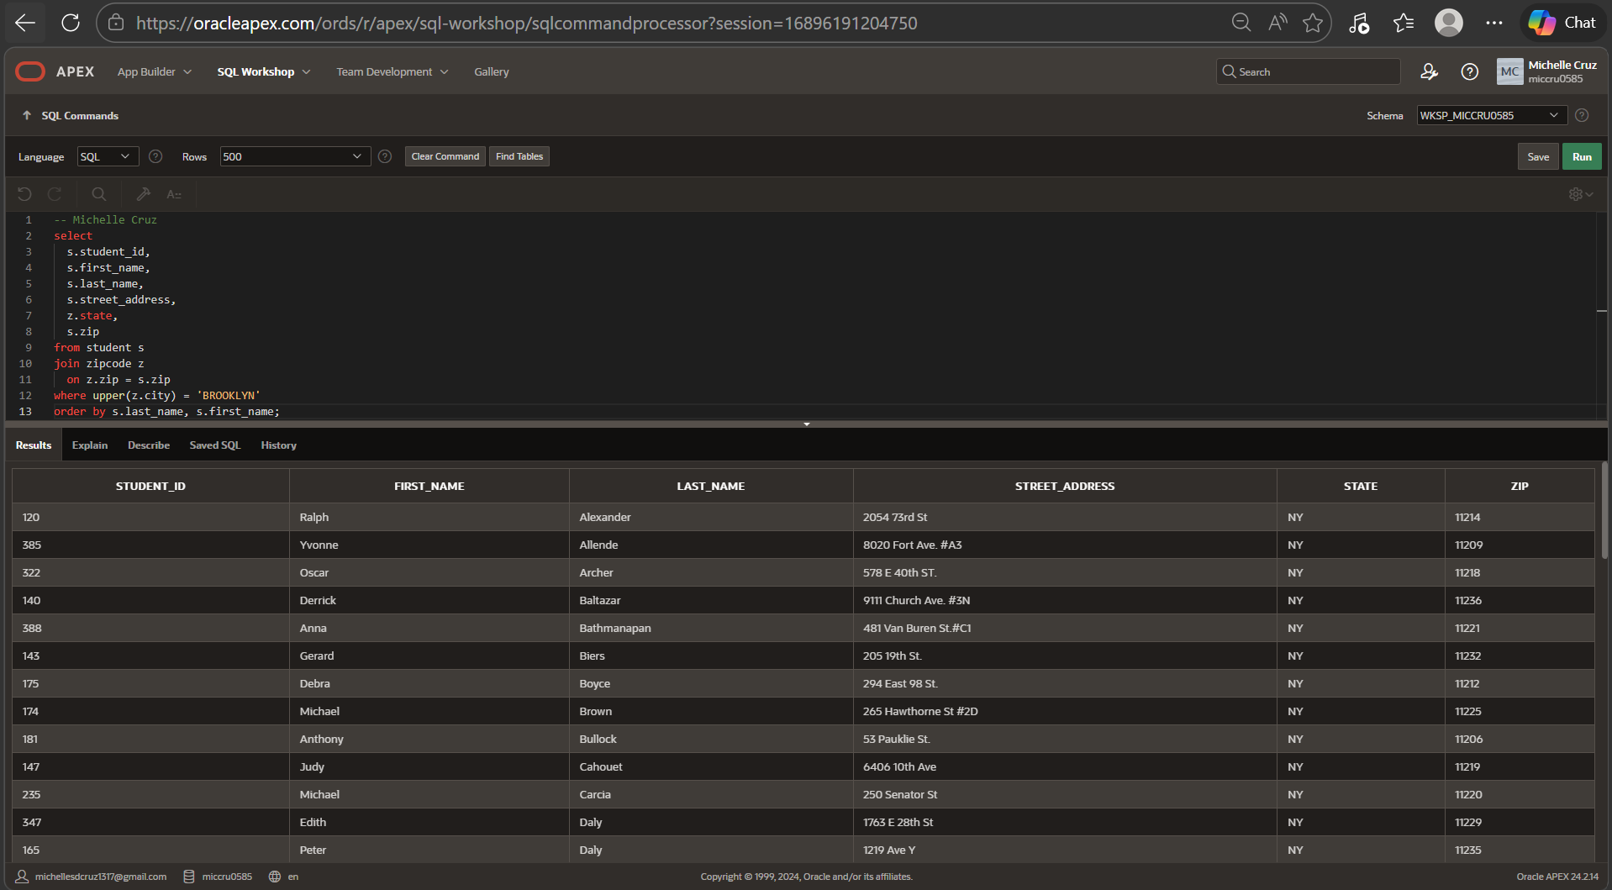
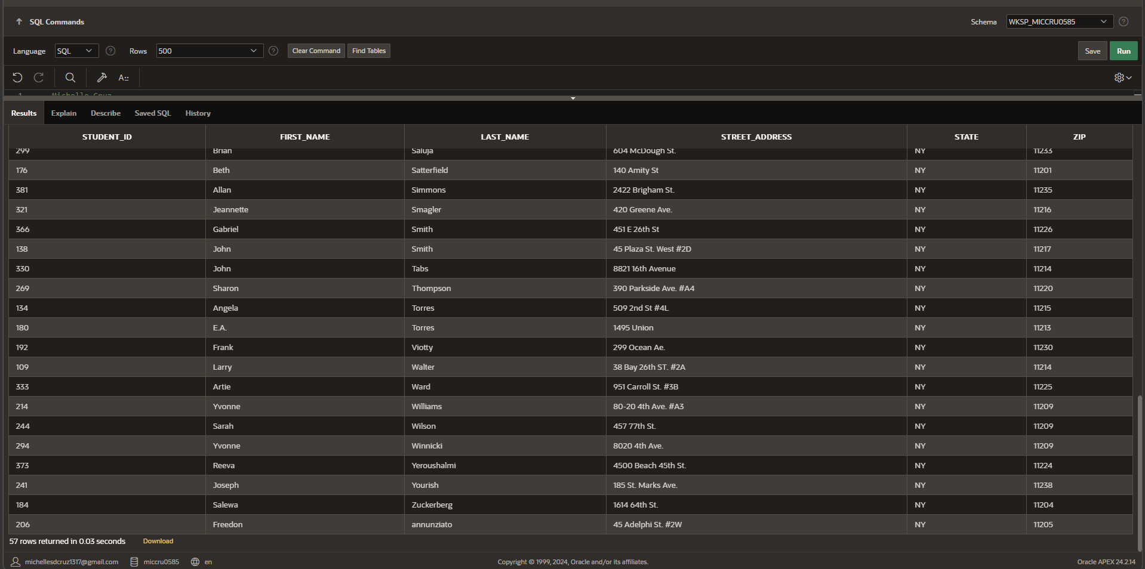

- Using the instructor and section table, list all the instructors and the number of sections they teach. Show first_name, last_name, and the number of sections they teach. Order your results by the number of sections in descending order.

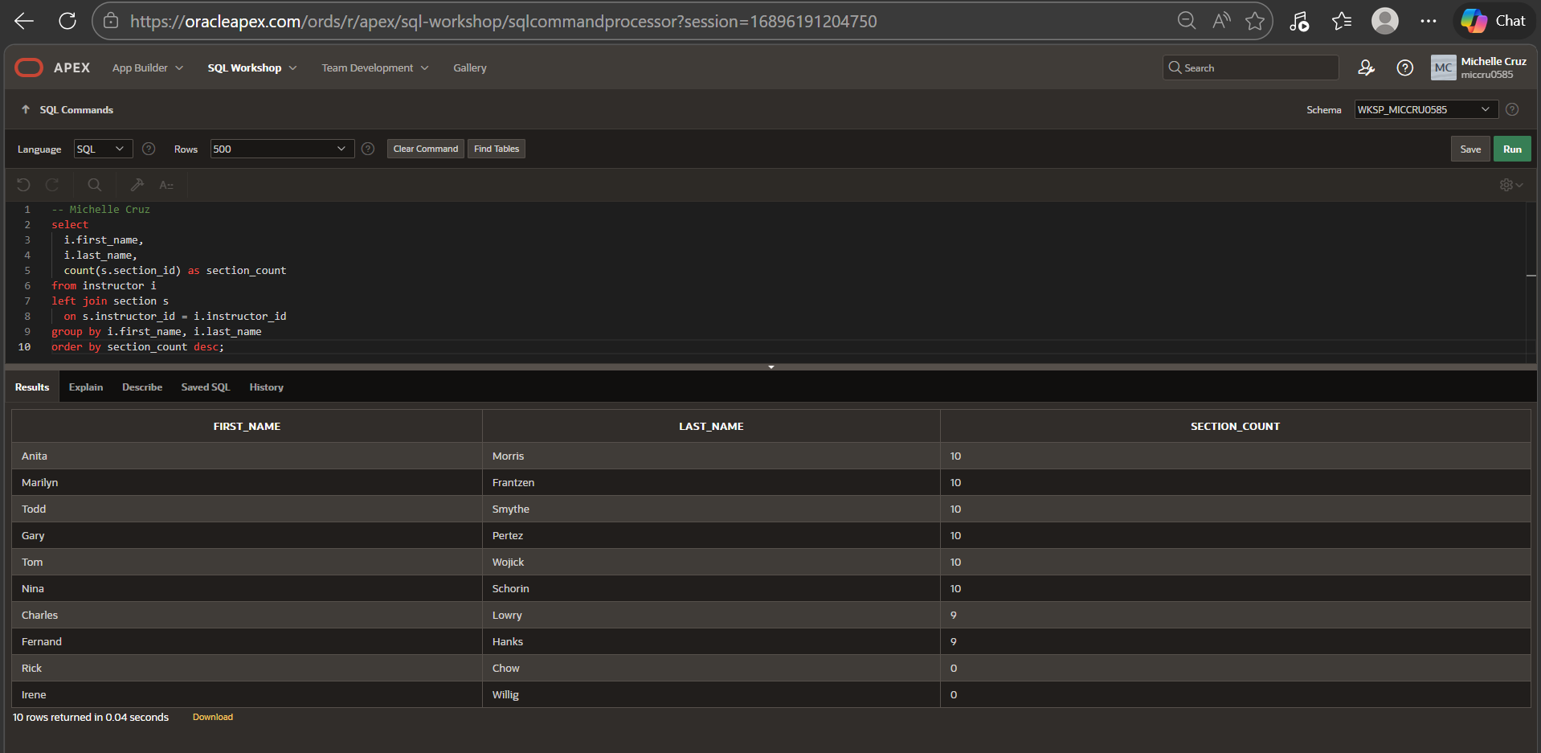

- List all the students who live in the same zipcode as the instructor Tom Wojick. Show first_name, last_name, street_address and zip in your results.

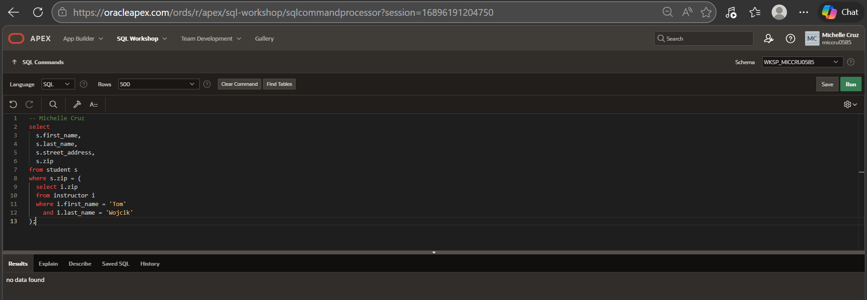

- List all the students who registered before Vera Wetcel. Show student_id, salutation, first_name, and last_name in your results.

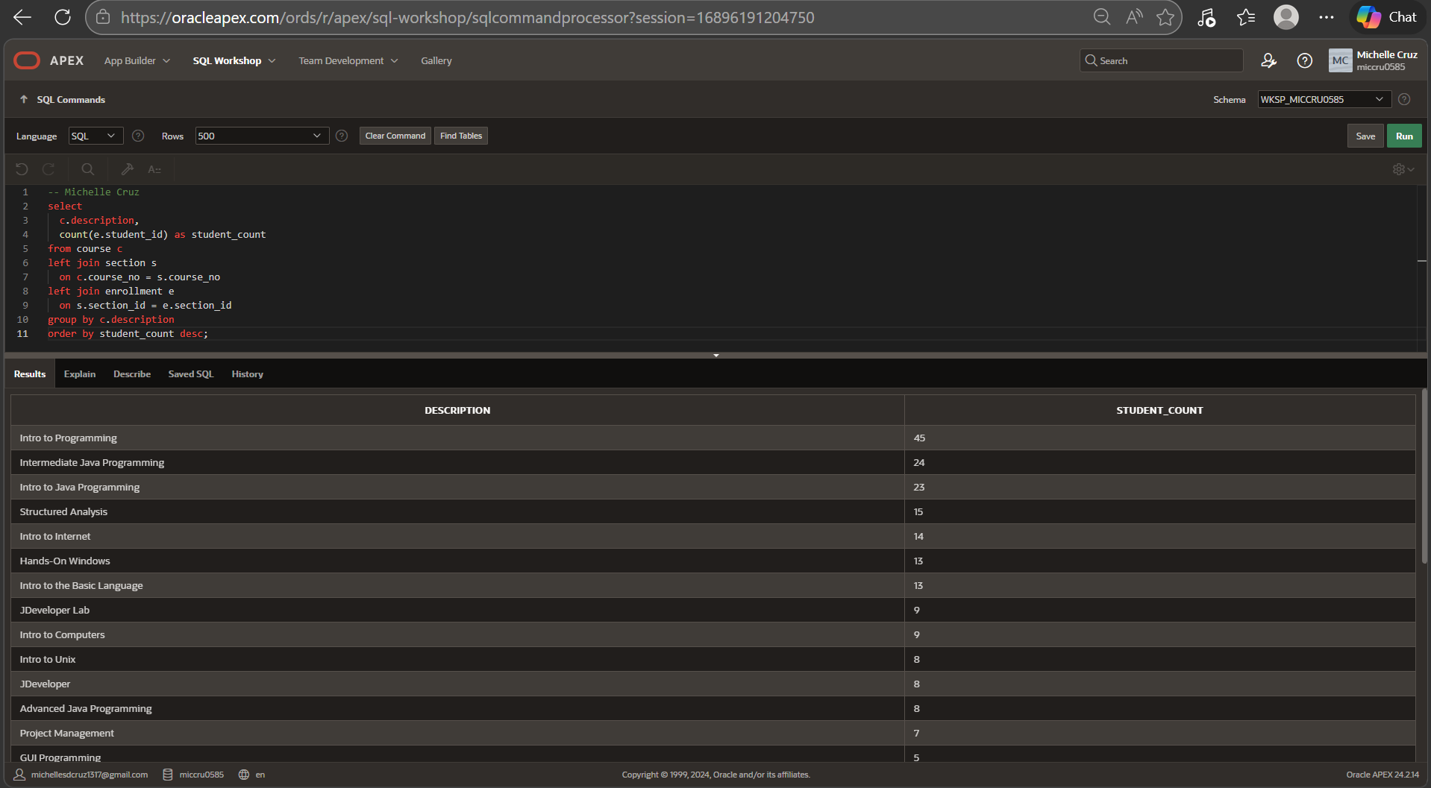
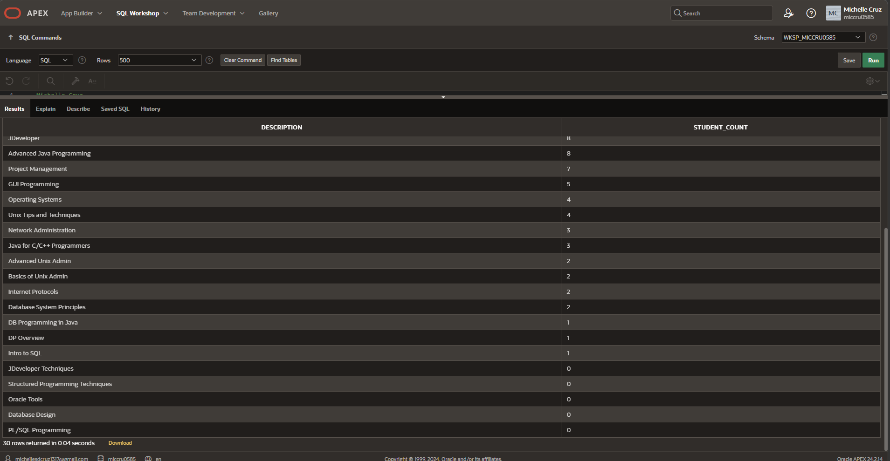

- Using the student and enrollment table, find all the students who haven’t enrolled in any classes. Show student_id in your results.

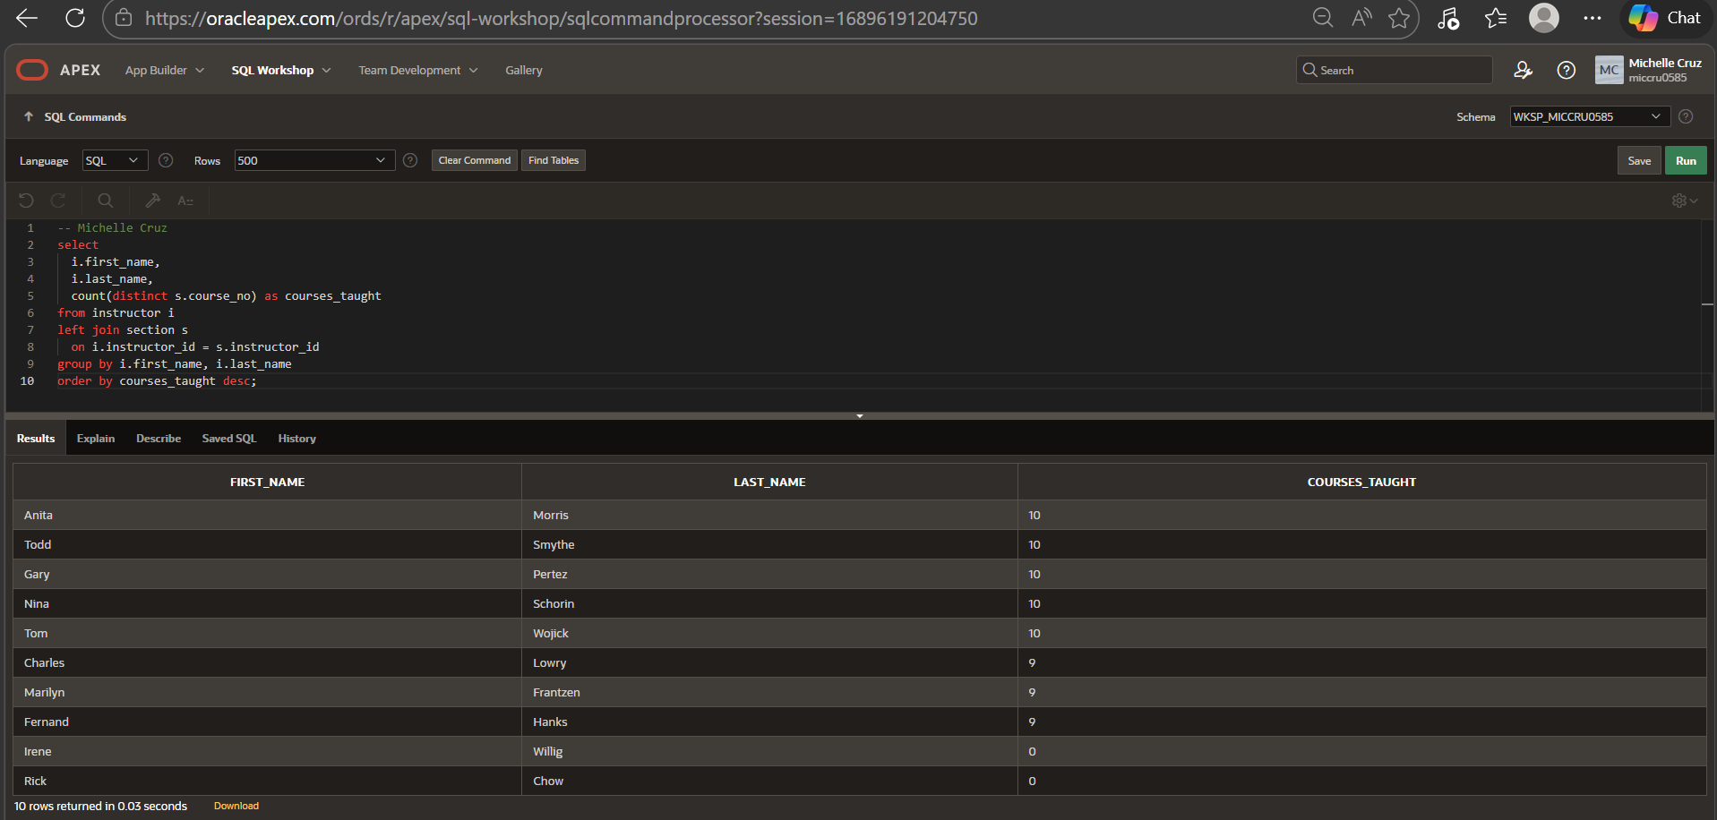

- Create a view called all_people_view that lists all the students and instructors currently present at the university. Show salutation, full_name, street_address, zip, phone in your results. The full_name column should be the “first_name last_name” columns from the tables.

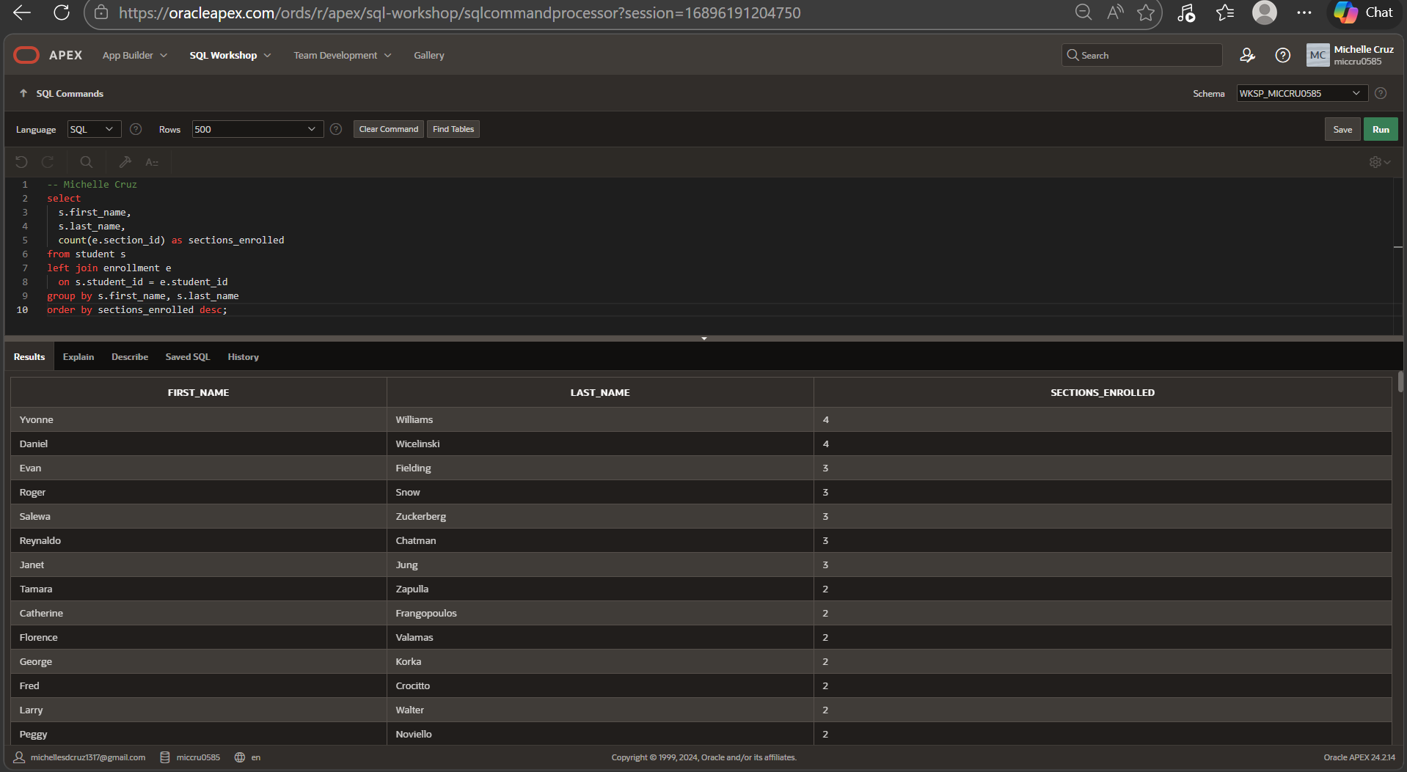
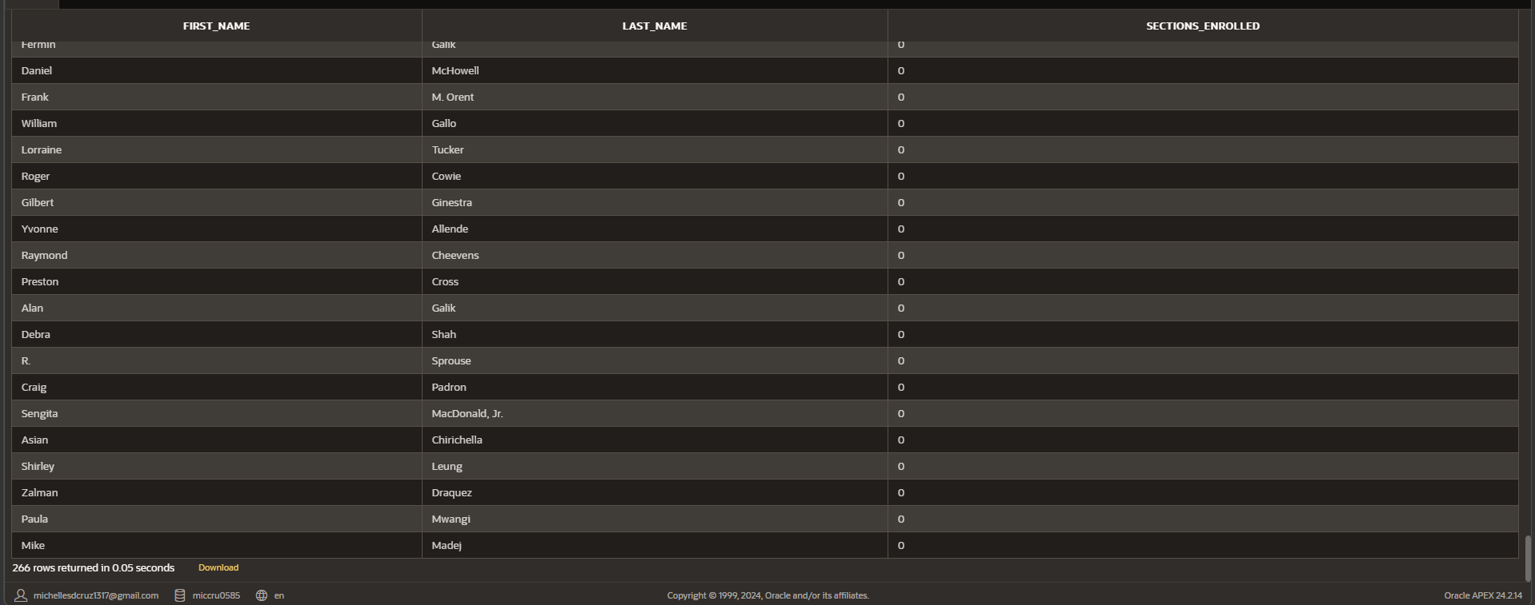

- From the enrollment and student tables, show the student who got the highest grade. Show first_name, last_name, and student_id in your results.

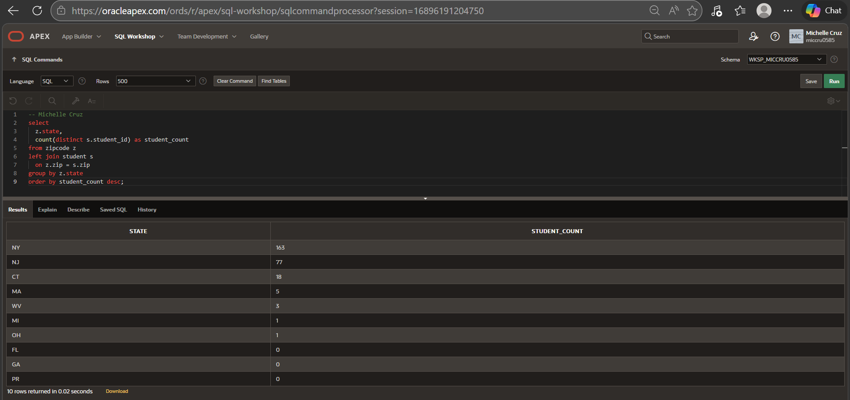

- Using the course, section tables, list all the courses who have more than 5 sections. Show course_no, description, and number of sections.

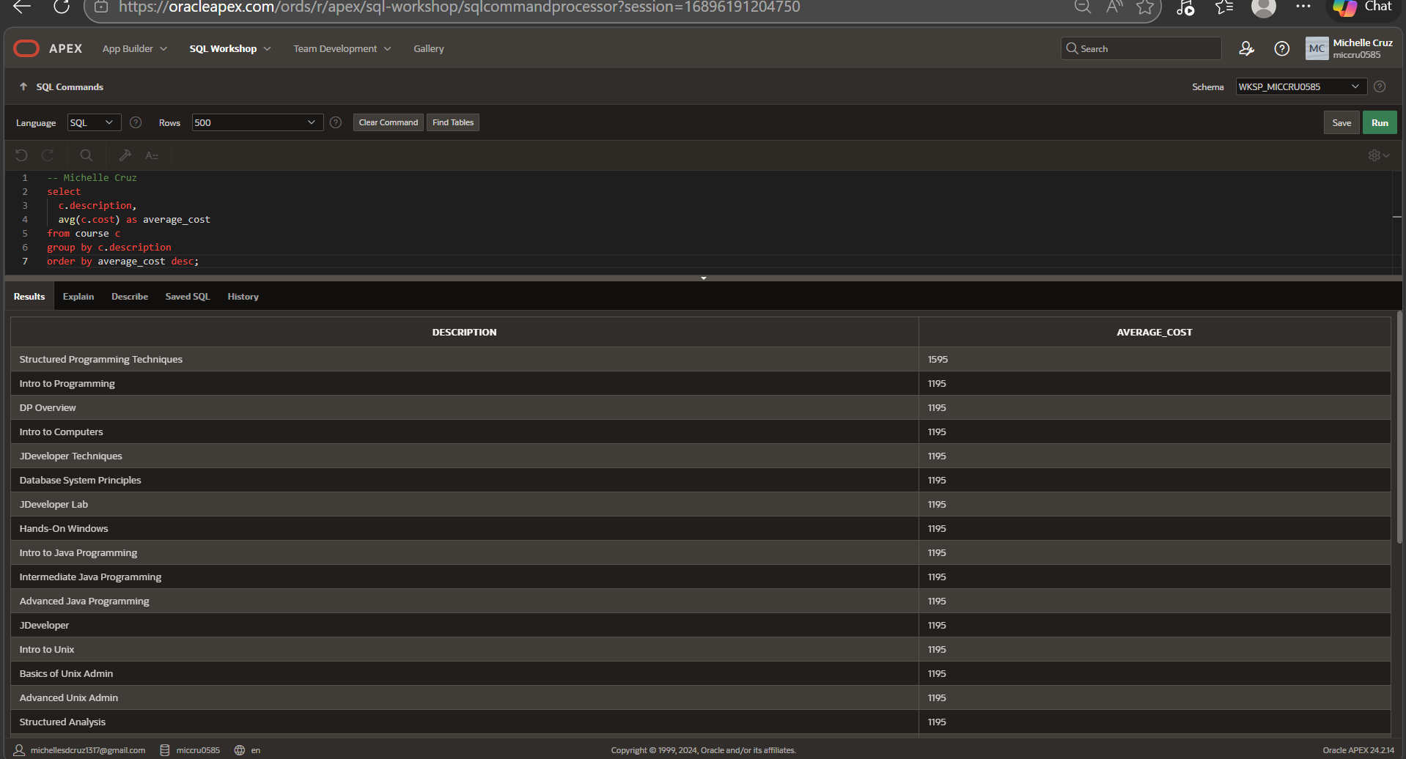
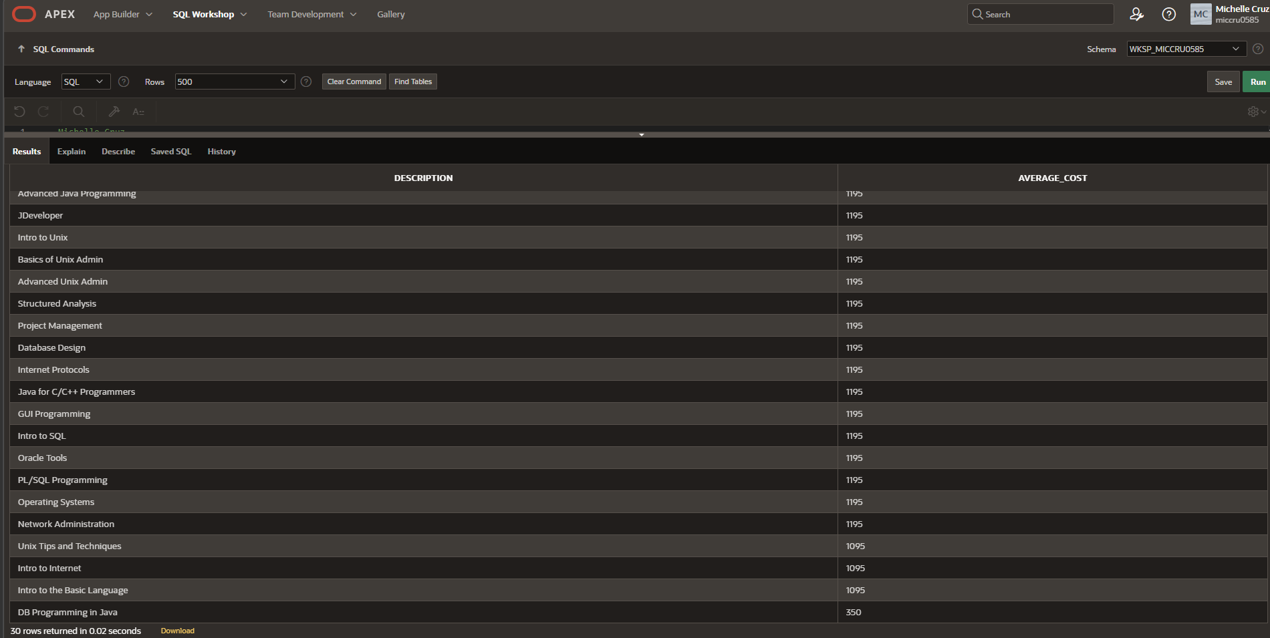

- List all the courses and their prerequisites (if any). Show course_no, description, cost of the course, and course_no, description of the prerequisite.

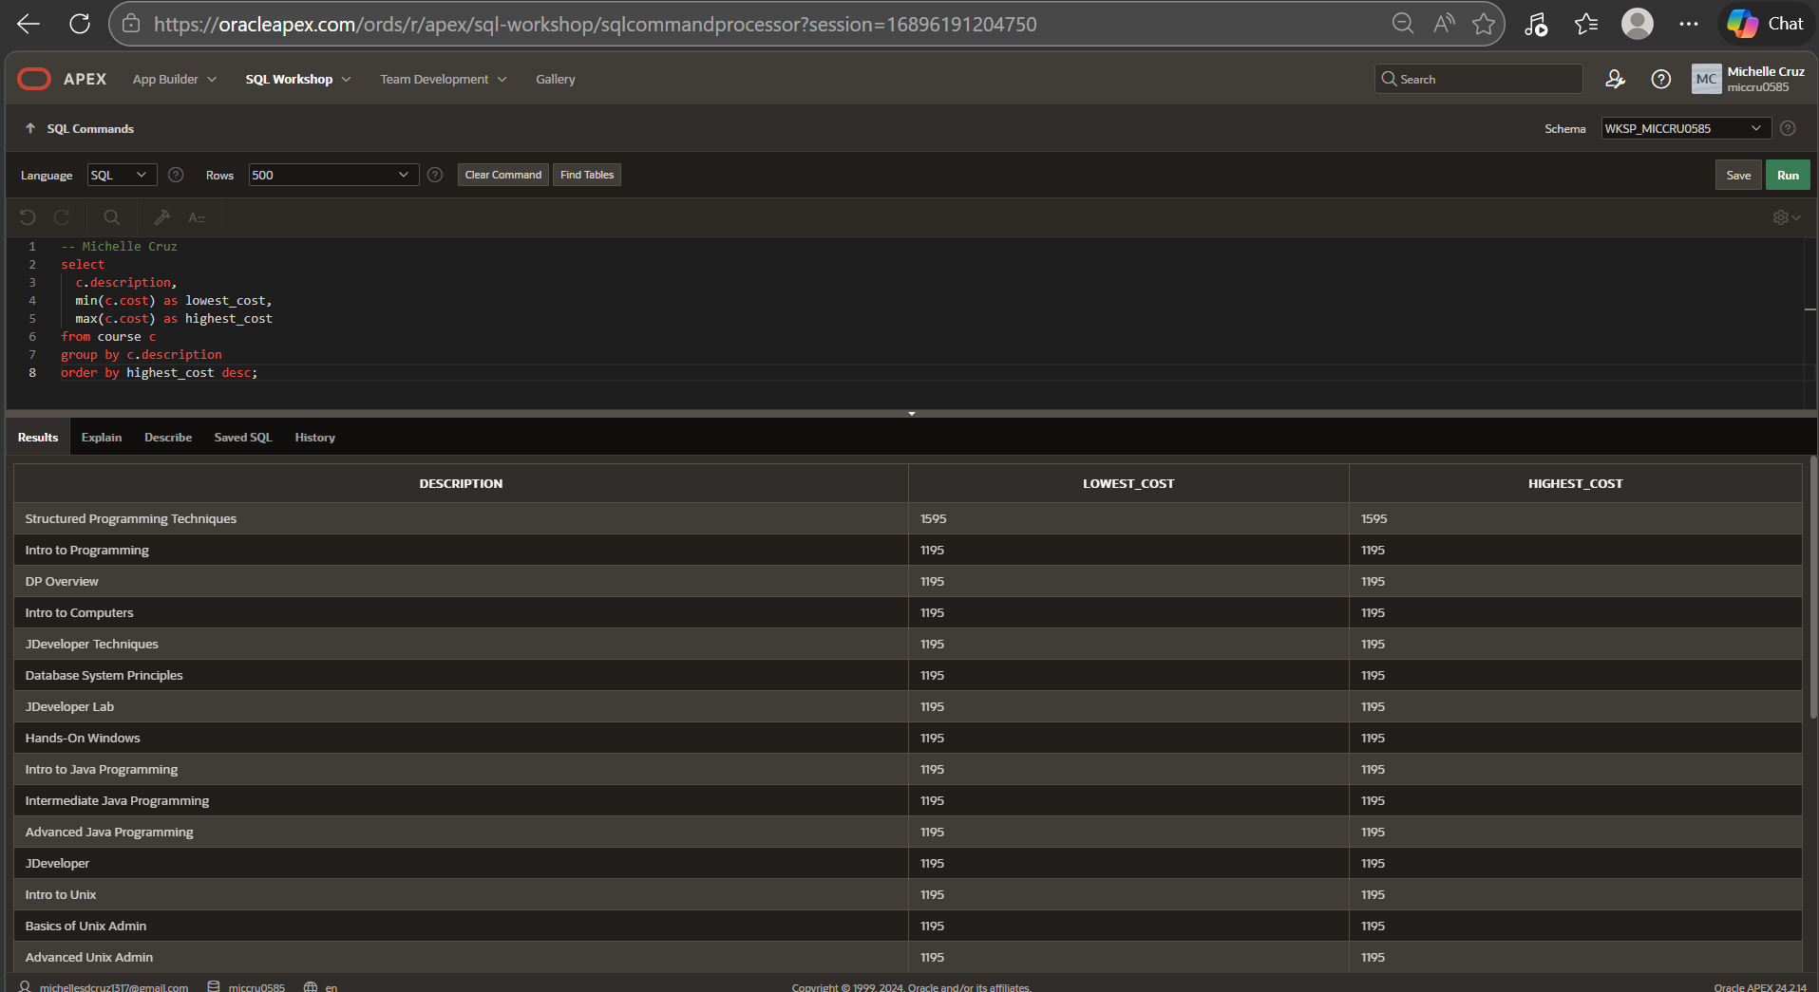

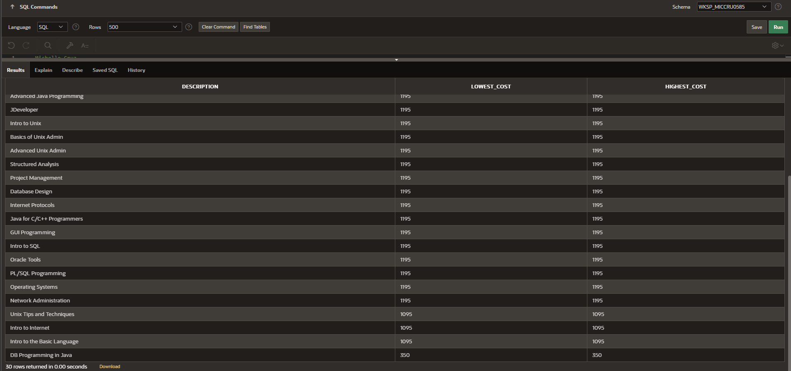

- List the course(s) who have the most sections. Show course_no, description, and number of sections in your answer.
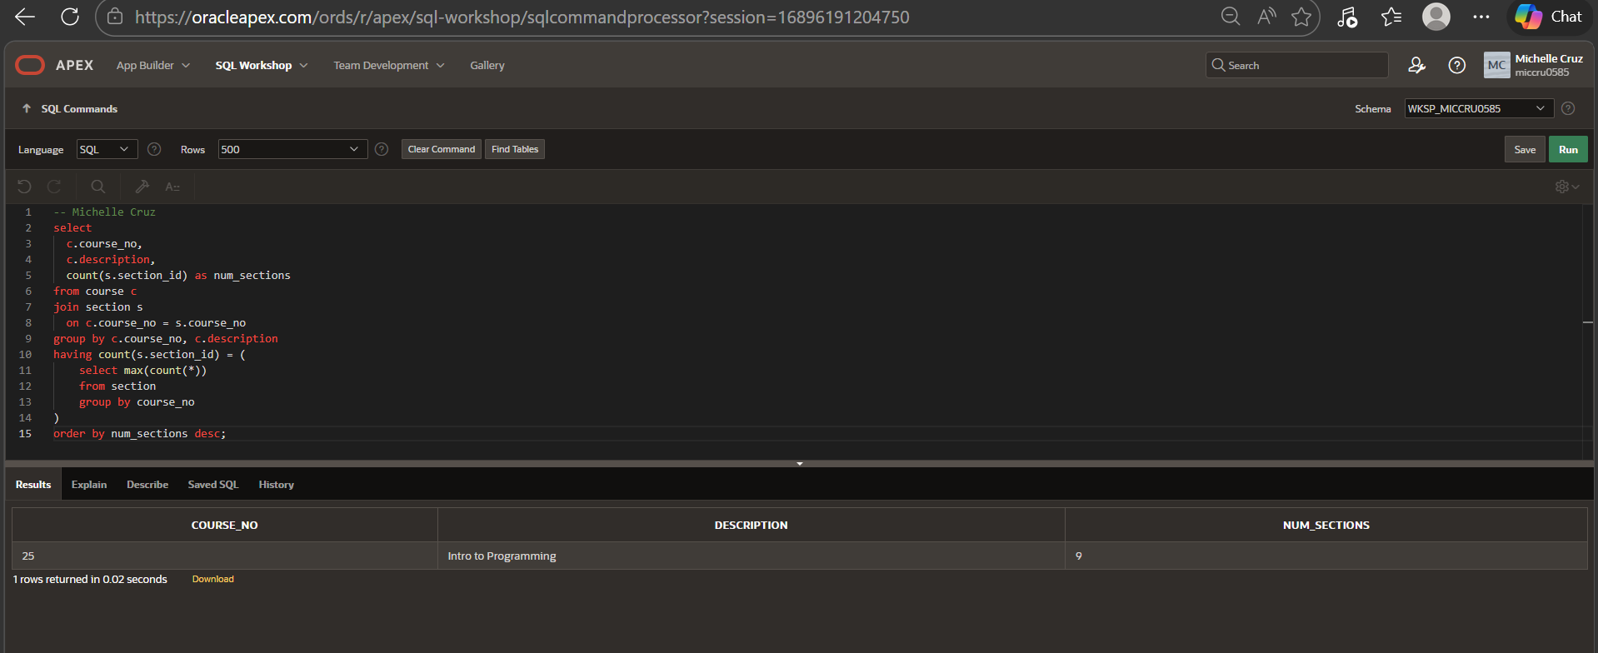

- Using the course, section, and enrollment tables list all the courses that have more students enrolled than their capacity allows. Show course_no, description, start_date_time, capacity, and current number of enrolled students in your results.

